UNIVERSITY OF GHANA, LEGON
DEPARTMENT OF STATISTICS
ASTA607_22424303
Question 1a
Description of the dataset
AThe crabs data frame has 200 rows and 8 columns, describing 5 morphological measurements on 50 crabs each of two colour forms and both sexes, of the species Leptograpsus variegatus collected at Fremantle, W. Australia.
Source
Campbell, N.A. and Mahon, R.J. (1974) A multivariate study of variation in two species of rock crab of genus Leptograpsus. Australian Journal of Zoology 22, 417–425.

References
Venables, W. N. and Ripley, B. D. (2002) Modern Applied Statistics with S. Fourth edition. Springer.

Question 1b
Loading the data and displaying its structure
'data.frame': 200 obs. of 8 variables:
$ sp : Factor w/ 2 levels "B","O": 1 1 1 1 1 1 1 1 1 1 ...
$ sex : Factor w/ 2 levels "F","M": 2 2 2 2 2 2 2 2 2 2 ...
$ index: int 1 2 3 4 5 6 7 8 9 10 ...
$ FL : num 8.1 8.8 9.2 9.6 9.8 10.8 11.1 11.6 11.8 11.8 ...
$ RW : num 6.7 7.7 7.8 7.9 8 9 9.9 9.1 9.6 10.5 ...
$ CL : num 16.1 18.1 19 20.1 20.3 23 23.8 24.5 24.2 25.2 ...
$ CW : num 19 20.8 22.4 23.1 23 26.5 27.1 28.4 27.8 29.3 ...
$ BD : num 7 7.4 7.7 8.2 8.2 9.8 9.8 10.4 9.7 10.3 ...

>

Question 1c
Frequency table for species and sex
F M
B 50 50
O 50 50

Question 1d

Bar Chart
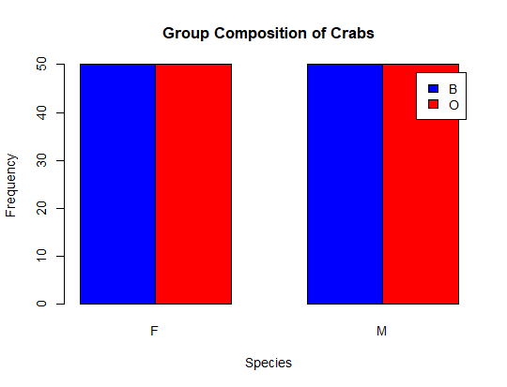

Question 1e

The dataset is balanced across all groups since all the groups has the same sample size of 50. Also, this will enable us to conduct further analysis like the ANOVA or a t-test.

Question 2
Construct a side-by-side boxplots of the body depth for the four groups

###6. Construct a side-by-side boxplots of the body depth for the four groups defined by the species and sex
boxplot(crabs$BD ~ crabs$sp + crabs$sex, main="Boxplot of Body Depth by Species",
col=c("blue","red"),ylab="Body Depth", xlab="Species")
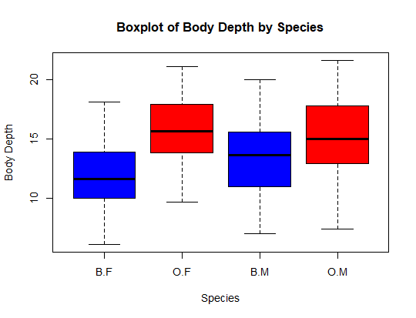

Question 2b
Identify any outliers and compare the central tendencies
In a boxplot, outliers are represented by individual points (dots or circles) plotted beyond the reach of the whiskers and from the plot, there are no outliers visible in any of the four groups. All data points for Body Depth fall within the calculated whiskers.
Comparison of Central Tendency (Medians)
The central tendency is represented by the thick horizontal black line inside each box. The Orange Female (O.F) group has the highest median body depth. The lowest central tendency is the Blue Lowest is the Blue Female (B.F) group Species Comparison: Generally, the Orange species that is the O.F and O.M shows a significantly higher central tendency for body depth than the Blue species (B.F and B.M).

Sex Comparison within Species
In the Blue species, males (B.M) have a higher median body depth than females (B.F).
In the Orange species, the females (O.F) surprisingly have a slightly higher median body depth than the males (O.M).

Spread and Distribution
Orange Male group appears to have the greatest spread (largest box and longest whiskers), indicating that body depth is most variable in that group. The Blue Female group is the most consistent (smallest box).

Question 3a
Produce a histograms of carapace length(CL) for each of the four groups defined

hist(crabs$CL[crabs$sp == "B" & crabs$sex == "M"], main="Histogram of Carapaces",
xlab="Carapace Length", col="blue", ylab="Frequency")
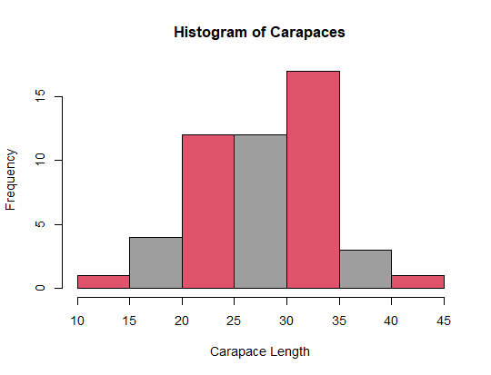

Question 3b
Describe and compare the sharps of the distributions, commenting on skewness and modality

Modality (Number of Peaks)
The distribution is bimodal, this means that is, it has two distinct peaks indicating the fact that the dataset contains two distinct sub-groups (males and females). The first peak occurs in the 20–25 carapace length interval, with a frequency of 12. The second (and taller) peak occurs in the 30–35 interval, with a frequency of approximately 17.
The distribution is moderately left-skewed (negatively skewed). Even though there are data points on both ends, the tail of the left side that is starting from 0 is slightly longer and thinner than the right side, which drops off more sharply after 40.
This means that the means the mean carapace length is slightly lower than the median, as it has drop down by the smaller carapaces in the 10–20 range.

For Sharp and Spread
The range of the carapace lengths spread from a minimum of 10 to a maximum of 45. The bulk of the data is concentrated between 20 and 35, where the two primary modes are located. Also, there are no zero frequencies between 10 and 45, indicating a continuous range of measurements in the dataset

Question 4a
Compute the mean of each of morphorlogical measurement (FL, RW,CL,CW,BD) by sex
aggregate(crabs[,c("FL","RW","CL","CW","BD")], by=list(crabs$sex), FUN=mean)
Group.1 FL RW CL CW BD
1 F 15.432 13.487 31.360 35.830 13.724
2 M 15.734 11.990 32.851 36.999 14.337

Question 4b
Onstruct a group bar chart to display the mean of each morphological measurement
barplot(t(aggregate(crabs[,c("FL","RW","CL","CW","BD")], by=list(crabs$sex),
FUN=mean)[,-1]), beside=TRUE,
main="Mean of Morphological Measurements",xlab="Measurement",
ylab="Mean Value", col=c("blue","red"), legend=TRUE,xlab="Measurement")
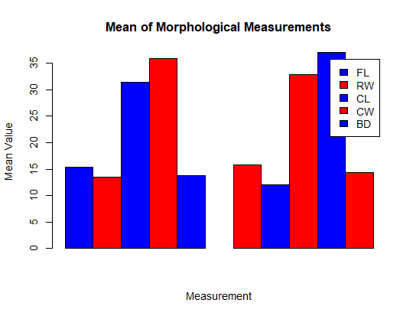

Question 4c
Identify which measurement shows the greatest species difference and which shows the least sex variation?
CW (Carapace Width) shows the greatest numerical difference between the Blue and Orange species. Carapace Width is the largest morphological dimension measured. Orange crabs are significantly larger than Blue crabs across all measurements
Least Sex Variation
The first bar, Blue in the left corner of the chart representing female is almost identical in height to the first bar in the right corner (Males), visually confirming that sex has little impact on this specific measurement.

Question 5a
Produce a scatterplot matrix (pairs plot) of five measurements
?pairs
pairs(crabs[,c("FL","RW","CL","CW","BD")],
main="Scatterplot Matrix of Morphological Measurements",
pch=19, col=crabs$sex)
onsi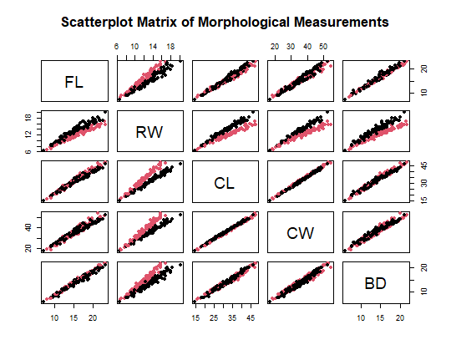

Question 5b
From the above matrix Scatter plot, all the five variables have positive relationship. Most variables show a very tight clustering of data points along an upward-sloping straight line which reflects the fact that as one variable increase, the other variables increase proportionately. Take for instance BD(Body Depth) and CW(Carapace Width), as BD increases, CW also increases.
Hence there is a strong positive correlation between the variables.
Again, measurements such as CL (Carapace Length), CW (Carapace Width), and FL (Frontal Lobe) appear to have the strongest correlations with each other, as demonstrated by the linear patterns in their respective plots.
RW (Rear Width) and BD (Body Depth) show slightly more dispersion compared to the CL-CW-FL group.

